**Milestone 9:**

**Goal**: Implement a basic **deployment pipeline**

You need to **perform** the following **steps**:

* Code check-in should automatically deploy the latest code.

**Steps for creating pipeline:**

**🡪** Giving name to codepipeline and choosing service role

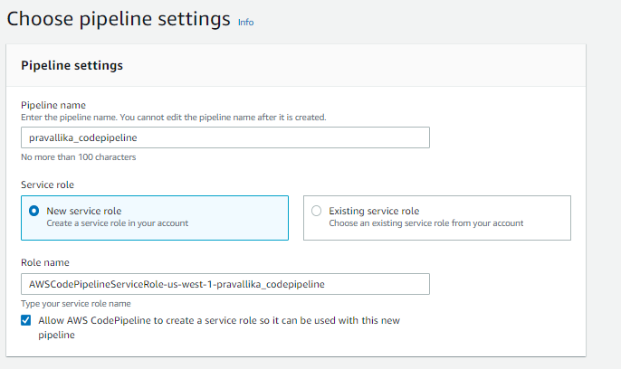

* Graphical user interface, text, application, email

  Description automatically generatedChoosing Bucket

🡪Choosing source as Github(Version1) & Grant AWS CodePipeline access to your GitHub repository

🡪 Skipping build stage

🡪 Adding deploy stage & Choosing deploy location in s3 bucket

🡪CodePipeline triggered successfully

🡪Code deployed in the bucket successfully

